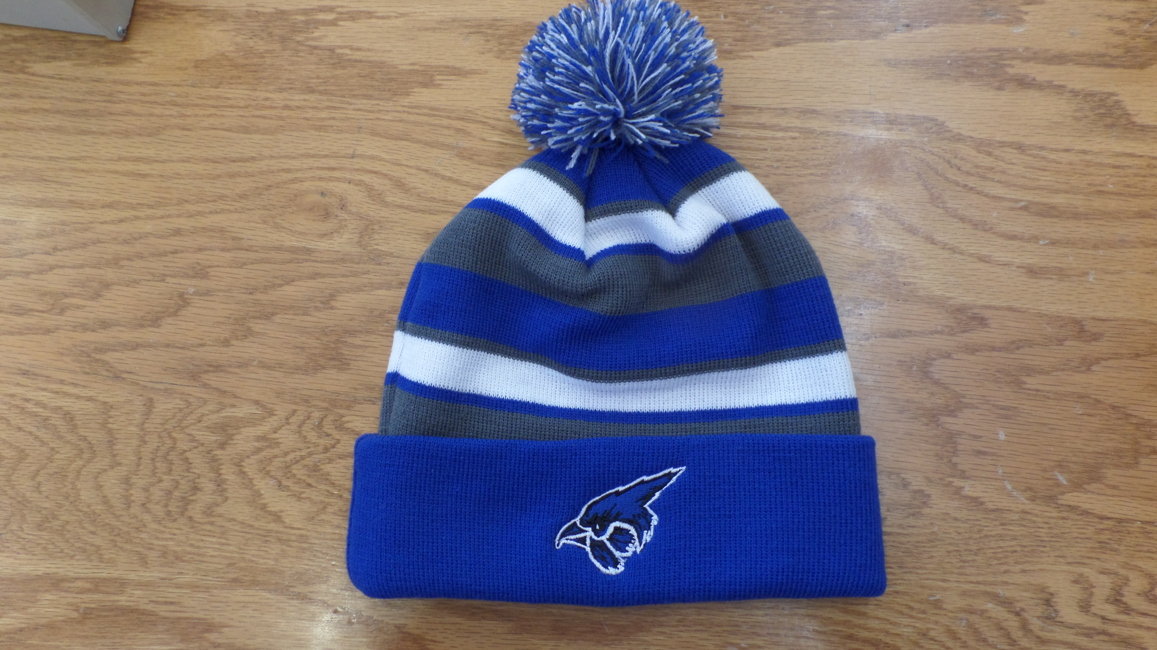
Striped Socking Hat

$17.00

Pierce Track Team
Contact Tim Waldner
twaldner@esu8.org

